Skills Workshop # 4: Library Research

Speaker: James Clasper
Date: Friday,, Jun 17, 2016
Time: 2:30 – 4:00 PM
Venue: University of Cincinnati, CEAS Library, 8th Floor, Baldwin Hall

Prepared by:
Mike Day, Reading High School, Cincinnati, Ohio
RET Participants for Project #2: “Supercapacitors”

This session was given by James Clasper, a librarian for the last 42 years. Twenty-six of these have been spent at the University of Cincinnati. Jim serves as the assistant Engineering and Applied Science librarian in the CEAS Library where he provides engineering reference/research assistance, selects engineering, mathematics, and physics books to purchase, and conducts library instruction sessions. He has a Master’s Degree from SUNY Geneseo and a Master’s Degree in Library Science from the University of Wisconsin-Madison (1975).

Mr. Clasper started the session by stating that any article or book that was not found directly in the library here, could be delivered within 24 hours. We could also use the inner-library loan program, known as ILLIAD. This service also has a short turn around period.

Next he demonstrated how to search the CEAS Library website. Located at the bottom of the website page are many different links for finding books, journals, and papers. (Figure 1)

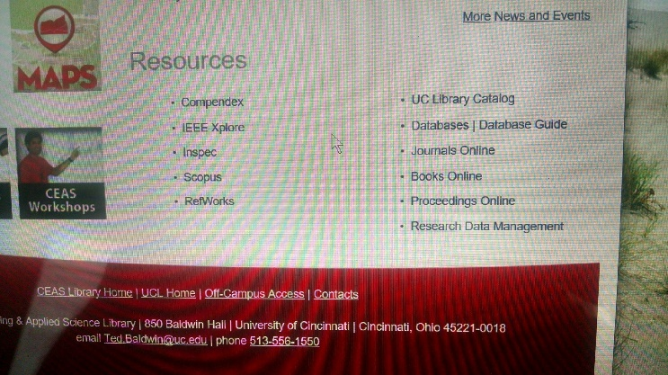
Figure 1. CEAS Library Website List of Resources

Compendex, Inspec, and Scopus were discussed as being good links to find articles that one might use to research topics. A prominent resource in this list is OhioLink. OhioLink is a statewide academic consortium of libraries that will find books or articles that might not be available at UC. OhioLink can even be used at a public library. SearchOhio is a link to find books in the public library system.

To find books, the link Books Online proved to be quick and easy. Access to Books Online is found at the bottom of the page or under the heading Resources at the top of the page. The creator of this website tried to make it user friendly by placing these links in multiple locations. (Figure 2)

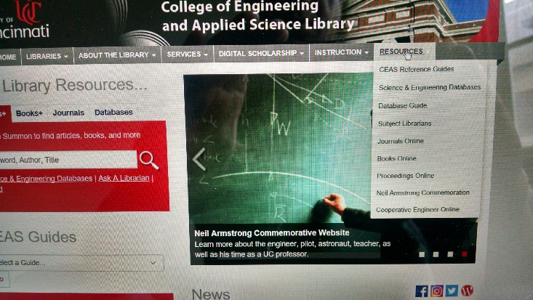
Figure 2. CEAS Library Website Separate List of Resources

After clicking on Books Online, there are many more websites available to locate books. Mr. Clasper mentioned some of the more prevalent ones: Wiley, Springer, and Knovel. ProQuest, is helpful in researching engineering articles related to the RET research projects. (Figure 3)

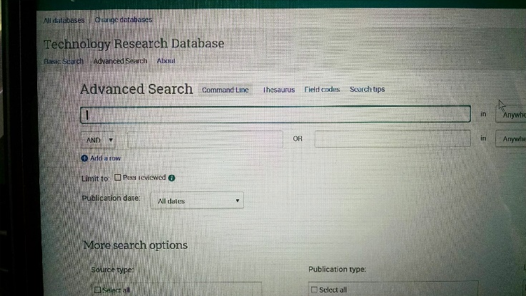
Figure 3. ProQuest Advanced Research Keywords

Once you have selected the sites to use, begin searching by placing keywords in the search box. Start with a general term such as “supercapacitor”. Make a search deeper by placing another keyword in the next search box. Choices can include And, Or, or Not to narrow the search.

Mr. Clasper continued by showing us RefWorks. RefWorks, does not require you to open an account, if one is not already established. Now that you have all your resources place them in a bibliography. Lastly, find the book or article and follow the steps listed.

Steps for RefWorks:
- Find the book or article
- Click on UC ArticleLinker
- Click on Export
- Make sure the Directly to RefWorks is filled in and click Export at the bottom

It is that easy. Once a list is established in RefWorks, simply create a bibliography by using the ASCE style for bibliographies. It sure beats the old way of creating a bibliography.

Teachers from the RET program were actively engaged in this session and were constantly asking questions. (Figure 4)

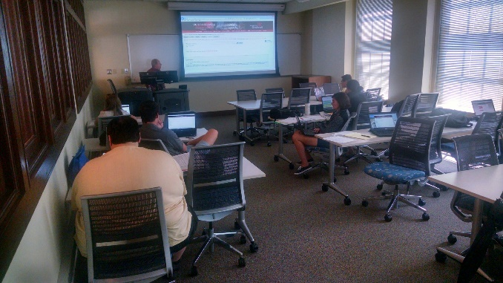
Figure 4. RET Participants Working On Researching CEAS Library Website

This session, given by James Clasper, was very helpful to the RET teachers in conducting literature searches for their research projects.

